

Sadiqa khursheed

FA20-BCS-078

MAD Theory Assignment 2

Submitted to: Sir Kamran

Array Built in Functions

Following are the built in functions of an array in JavaScript:

**Array.isArray():**

This function checks if the given value is an array or not.

**Array.prototype.concat():**

This function is used to merge two or more arrays into a single array.

Code:

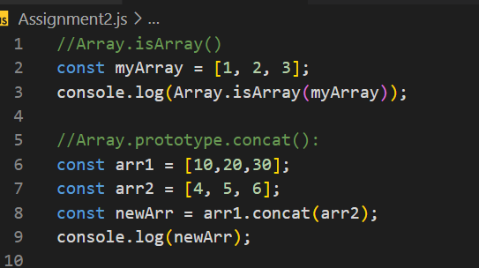

Output:

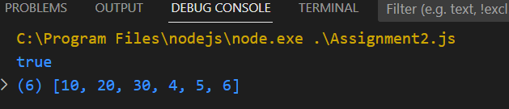

**Array.prototype.push():**

This function adds one or more elements to the end of an array.

**Array.prototype.pop():**

This function removes the last element from an array.

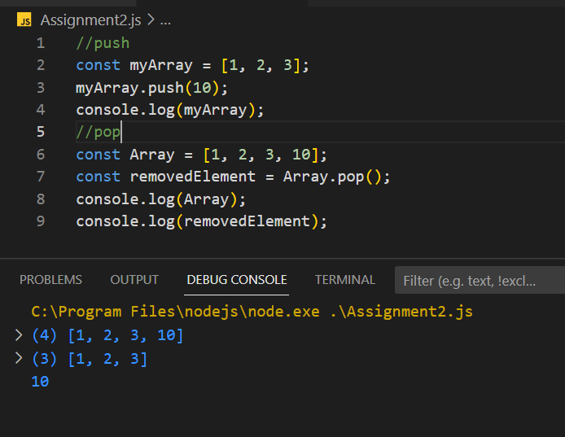

**Array.prototype.shift():**

This function removes the first element from an array.

**Array.prototype.filter():**

Filter() takes a function as an argument and returns a new array with all the elements in the original array that pass a certain condition defined by the function.

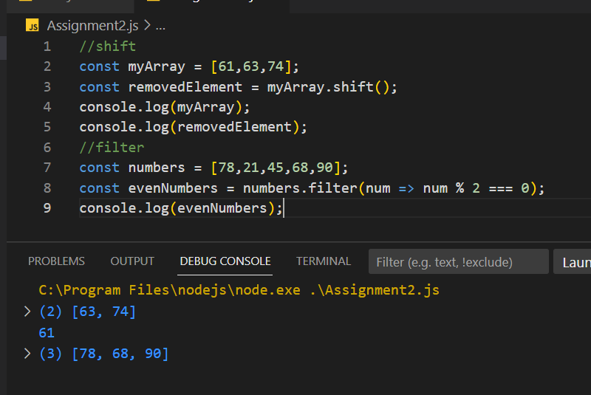

**Array.prototype.map():**

Map() takes a function as an argument and applies that function to every element in the array, creating a new array with the transformed values.

**Array.prototype.unshift():**

This function adds one or more elements to the beginning of an array.

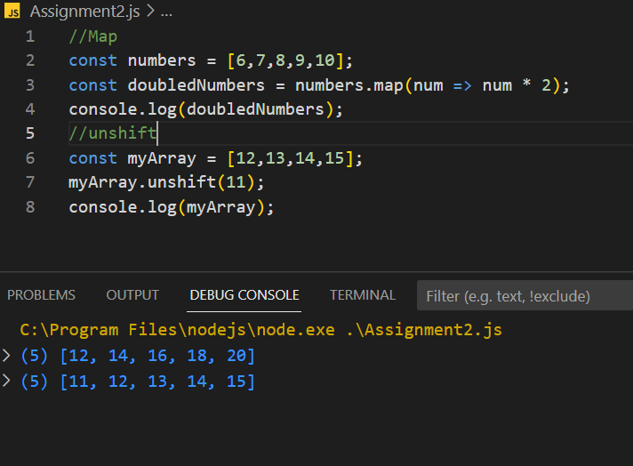

**Array.prototype.splice():**

This function adds or removes elements from an array.

**Array.prototype.slice():**

This function returns a new array that contains a portion of an existing array.

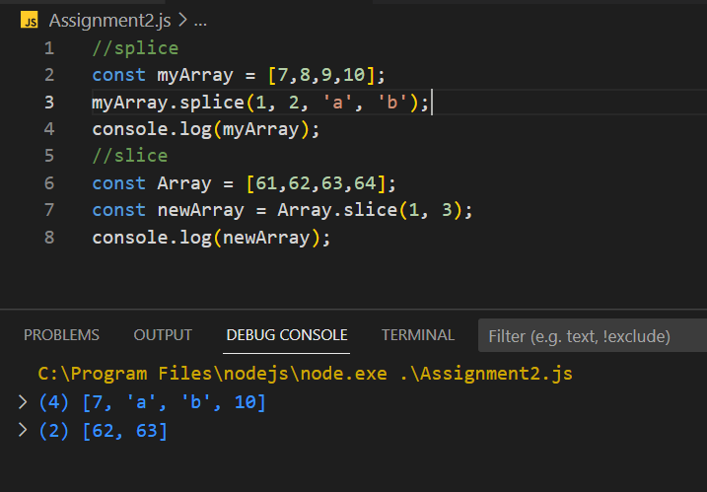

**Array.prototype.reverse():**

This function reverses the order of elements in an array.

**Array.prototype.sort():**

This function sorts the elements of an array.

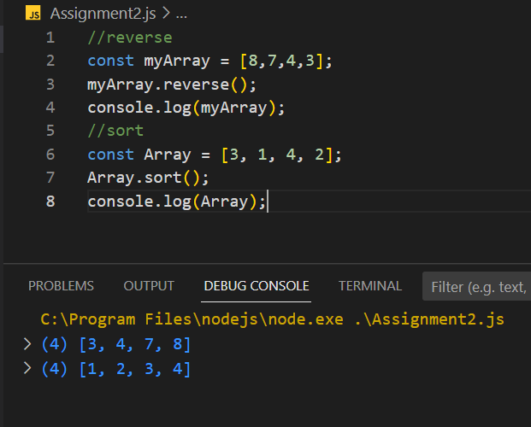

STRING FUNCTIONS

**String.prototype.charAt():**

This function returns the character at a specified index in a string.

**String.prototype.length:**

This property returns the number of characters in a string.

**String.prototype.indexOf():**

This function returns the index of the first occurrence of a specified value in a string.

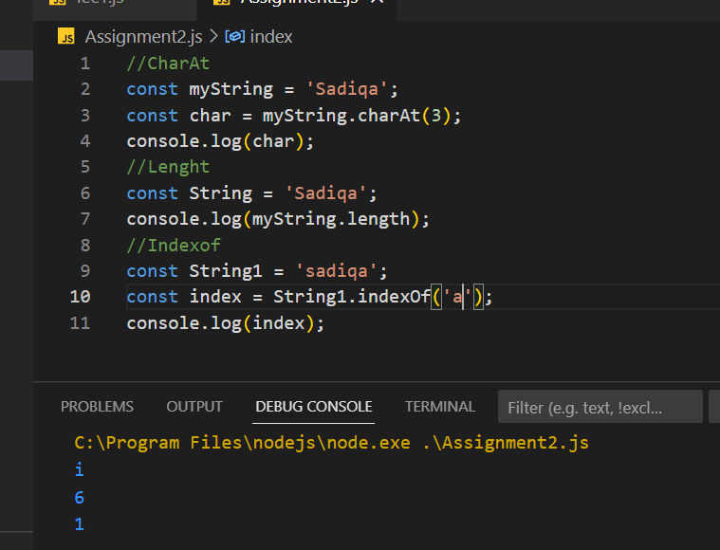

**String.prototype.lastIndexOf():**

This function returns the index of the last occurrence of a specified value in a string.

**String.prototype.slice():**

This function returns a portion of a string.

**String.prototype.substring():**

This function returns a portion of a string.

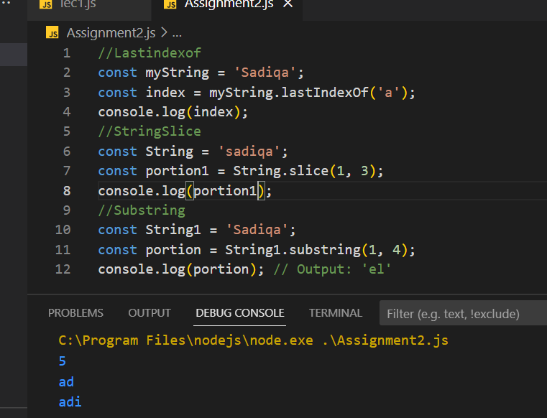

**String.prototype.replace():**

This function replaces a specified value with another value in a string.

**String.prototype.toLowerCase():**

This function converts a string to lowercase.

**String.prototype.toUpperCase():**

This function converts a string to uppercase.

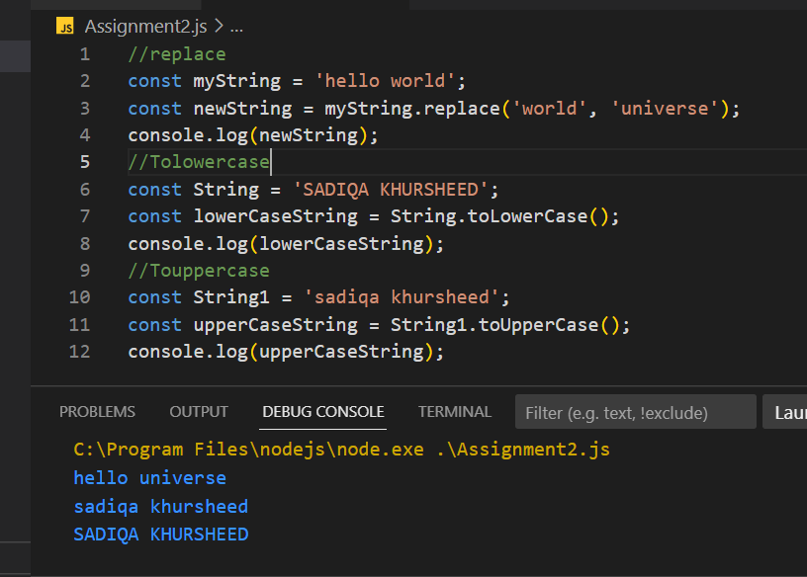

**String.prototype.trim():**

This function removes whitespace from both ends of a string.

**String.prototype.split():**

Splits a string into an array of substrings based on the specified separator.

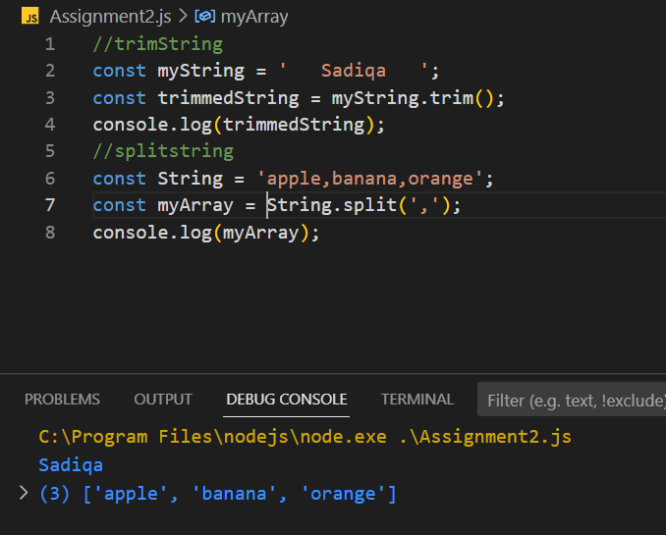

CHESS BOARD

import React from 'react';

import { View, StyleSheet, Text } from 'react-native';

const Board = () => {

    const board = [];

    for (let i = 0; i < 8; i++) {

        const row = [];

        for (let j = 0; j < 8; j++) {

            const color = (i + j) % 2 === 0 ? '#f0d9b5' : '#b58863';

            row.push(

                <View key={`${i}-${j}`} style={[styles.cell, { backgroundColor: color }]} />

            );

        }

        board.push(

            <View key={i} style={styles.row}>

                {row}

            </View>

        );

    }

    return <View style={styles.board}>{board}</View>;

};

const ChessScreen = () => {

    return (

        <View style={styles.container}>

            <Board />

        </View>

    );

};

const styles = StyleSheet.create({

    container: {

        flex: 1,

        alignItems: 'center',

        justifyContent: 'center',

    },

    board: {

        flex: 1,

        flexDirection: 'column',

        justifyContent: 'center',

        alignItems: 'center',

    },

    row: {

        flexDirection: 'row',

        justifyContent: 'center',

        alignItems: 'center',

    },

    cell: {

        width: 40,

        height: 40,

    },

});

export default ChessScreen;

